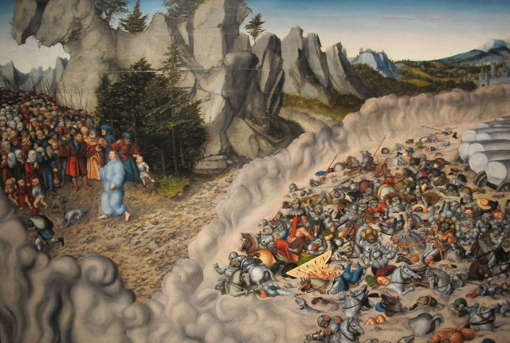
A Literary Analysis of the “Song of the Sea” – Exodus 15:1-18
The Exodus episode of the Yam Suph (Sea of Reeds) ends with a triumphal celebration of God’s act of deliverance from the Egyptian army. Scholars have long debated the timing and authorship of the Song, written as Hebrew poetry. D. Garrett has identified some interesting comparisons with Genesis. The Song mirrors the structure of the creation story, with three pairs of stanzas and a seventh stanza focusing on the rest of God. This comparison is apt given the creation focus of the Yam Suph episode (the breath/wind of God moving the water, the overthrow of chaos/gods in the water, the establishment of God’s rule).
The Literary Structure of the Song of the Sea
Song Division | Stanza | Verses | Title | Focus
First | 1 | 15:1cd – 3 | YHWH, the mighty God | - Praises YHWH by name for personal attributes  - Specifically speaks of destruction of Egyptians  - Strongly personal, uses first person pronouns
First | 2 | 15:4 - 5 | Victory over Egypt
Second | 3 | 15:6 - 7 | YHWH, the mighty God | - Describes the power God directs towards his enemies  - Highlights the attitude of the enemies towards YHWH and his people
Second | 4 | 15:9 - 10 | Victory over Egypt
Third | 5 | 15:11 | YHWH, the mighty God | - Praises YHWH as greater than all other gods  - Moves from past victory over Egyptians to future victories over Canaan
Third | 6 | 15:12 - 15 | Canaan in terror
Fourth | 7 | 15:16 - 18 | Rest in Canaan | - YHWH will continue to support the Israelites in the same way as they cross into the land, YHWH’s “inheritance” (not the people’s land)  - This inhabitance will be his “rest” which will go on forever

From Duane A. Garrett, A Commentary on Exodus. Kregel Exegetical Library. Grand Rapids: Kregel Academic, 2014.

